
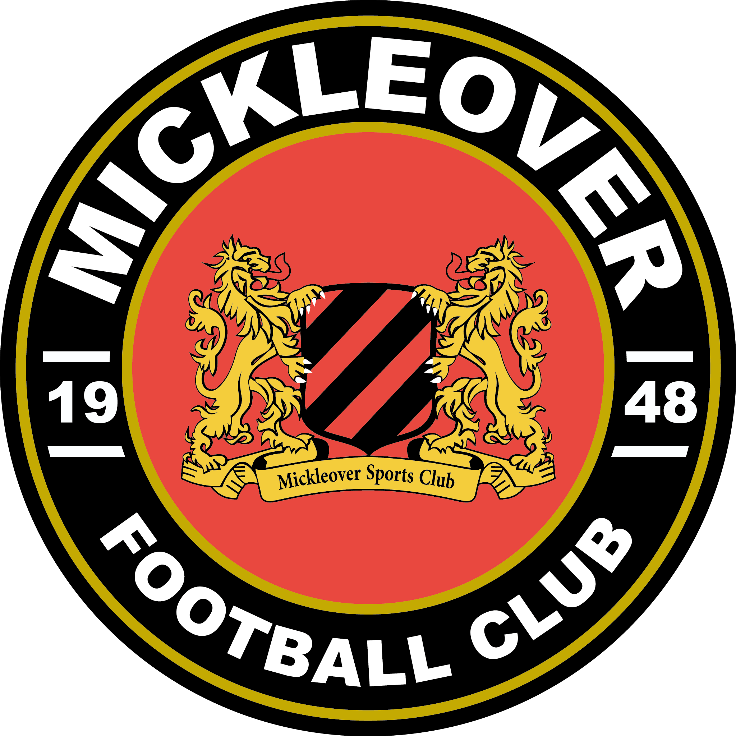
10 Week Couch to 5k
Mickleover Sports Club.
The Mickleover Joggers, 10 week Couch to 5k programme is a tried and tested way for beginners to start and learn to run.
Week one, session one. You will RUN!
We start with intervals of 1min 30 sec walking, and 1min running, then back to walking. For approx 8 repetitions.
The course is for both Monday and Thursday sessions. You will then be given 'homework' to complete over the weekend.
Homework is not compulsory but you will find it will help your fitness and running if you complete it.

Obviously, we all have personal commitments. If you can not attend a session, it's ok! Just let us know, and we can let you know what the session will be so you can still complete it in your own time.
Over the weeks, we increase the run time, and play about with the walk time. Both increasing and decreasing as you progress through the course.
At the end of the 10 weeks, and you have either ran a 5k non stop, or have run for 30 mins non stop, we then have a presentation evening at the Sports club. Here you can bring friends and family to share your achievement, and of course to mingle with other club members who have also supported you along the way.
Each session we meet in the car park at Mickleover Sports Club, on Station Road. And complete registration, we have a chat through what will happen in the session, the route we'll be taking and which co-jog leaders will be joining us.
Then we'll complete a short warm up. After the warm up, we run!
Once we have completed the session and have returned back to the sports club, we'll have a short cool down and then you're done till the next session.
The first 2/3 weeks the session will last for approx 30 min. This will increase over the weeks, but will be no longer than an hour in total.
Please ensure you wear suitable clothing and footwear. We understand that this may be new to you and you may not have the 'full gear' to start with. But don't worry. Leggings, shorts, jogging bottoms, t-shirts etc will be fine. Ladies, please ensure you wear a good sports bra, and try to stay away from strappy tops (trust me on this one!) Trainers, supported, new'ish. Try and stay away from the ones you do the garden in, or ones you've had for 5 years! (Again, trust me) Also remember this is England, and the weather can be temperamental at the best of times. You may wish to bring a waterproof jacket, or change of clothes. Yes, we do still run in the rain, and yes we do still run when it's sunny!
If you want to bring water with you please feel free. But we do have the bar available to us before and after the sessions.
Mickleover Sports Club has plenty of free parking, changing rooms, toilets and did we mention a bar?! So what now?
We have a strict capacity of 15 participants in our Couch to 5k course, so don't leave it too late.
This ensures our jog leaders can help and give you support. So first come first served!
If you've any questions or queries, please do get in touch: mickleoverjoggers@gmail.com

